The Gainsborough Parish Church CE Primary School

Positive Relationships & Behaviour Policy
Document Title | Positive Relationships & Behaviour Policy
Author | Theresa Peacock
Version Number | V2

Summary of Changes from Previous Version
Date | Author | Note/Summary of Revisions
October 2025 | Theresa Peacock | Refined after staff consultation around stepped consequences
March 2026 | Theresa Peacock | Reference to updated restrictive interventions guidance
May 2026 | Theresa Peacock | SEN hub revisions

School Vision
Journeying together with hope and aspiration
At Parish, we value each person as they are, seeing every member of our school family as a precious, unique individual and treating them with dignity. Seeking first to understand through the building of relationships, we live in a community of hope. We aspire to enable each person to be a curious learner, inspired to develop the knowledge and wisdom to make the world a better place. We strive to encourage all to fulfil their God-given potential, having a confidence in transformation for the better.

Rationale
At The Gainsborough Parsh |Church CE Primary School, we believe every child is valued, respected, and capable of great things. Our approach is rooted in unconditional positive regard—we see the best in every child and respond with empathy, consistency, and belief in their potential.
We are committed to creating a safe, nurturing environment where all members of our school community feel secure, supported, and proud to belong. Guided by our core values of Hope, Wisdom, Dignity, and Community, we teach children to work and play together with kindness, patience, and respect.
Through restorative practices and meaningful conversations, we help children understand the impact of their actions, make positive choices, and grow in character. We encourage fairness, tolerance, and responsibility, always focusing on what each child needs to thrive.

Aims
We aim to build a culture of positive relationships where every child feels safe, respected, and ready to thrive. Rooted in our Christian values of Hope, Wisdom, Dignity, and Community, we promote behaviour that supports learning, wellbeing, and belonging. We believe in unconditional positive regard—seeing the best in every child—and use restorative approaches to help repair and strengthen relationships. Our goal is to create a school community where behaviour is guided by fairness, consistency, and care.
Our aims are to:
- Encourage all children to make positive behaviour choices.
- Manage behaviour fairly, consistently, and with compassion.
- Use restorative practices to repair and restore relationships.
- Build a community where self-discipline and responsibility are nurtured.
- Approach all behaviour and relationships with equity and respect.

Our School Behaviours
Through Collective Worship themes, PSHE sessions and classroom discussions, staff and children will work collaboratively to explore the school values and our behaviour expectations. Children and staff will strive to always embody the school values and will explore the importance of representing Gainsborough Parish both within and outside of school. Our values will be vocalised by children and staff to promote positive attitudes towards behaviour in school. Our expected behaviours include (Appendix 2), but are not limited to:

Roles & Responsibilities
Child’s Roles & Responsibilities
To be ready to learn.
To be safe.
To look after each other and our school.
To be calm, kind and respectful.
To use a restorative conversation to help them take responsibility for their actions and plan next steps to repair any damaged relationships.
To take care and pride in being a member of the Parish family.
Family Roles & Responsibilities
Ensure your child attends school daily, arriving on time, ready to learn.
Promote that your children use polite manners, be kind to all and show considerate compassion for all.
Work in partnership with school to promote good behaviour, challenge and support negative behaviours and uphold the principles in this policy.
Understand and support school with strategies that are implemented in school.
Staff Roles & Responsibilities
Every member of staff will promote and grow our expected behaviours through:

Every member of staff will follow and understand our expected behaviours, by role modelling these skills to our children and displaying high expectations for all.
Every member of staff will ensure all our children are safe and respected.
Every member of staff will use restorative conversations to effectively repair behaviours, ensuring all children are treated fairly and feel supported.
All members of our school community will model and teach positive behaviour, good manners, calm and considerate thinking, and inclusive acceptance of all.
Every member of staff will model an appropriate level of volume in their voice, avoiding shouting at all costs, expecting the same in return from the children. Classrooms will be calm, safe spaces in which every voice is heard in turn.
Every member of staff will use ‘Silent Signal’ routines around school.
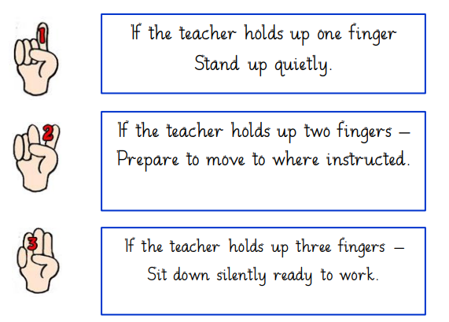
All children will be greeted with a warm welcome and a smile at the classroom door/and or the school gates by their teachers, teaching assistants and members of the Leadership team.

Rewards & Praise
At Gainsborough Parish, we believe that every child is valued, respected, and capable of making positive choices. Our approach is rooted in unconditional positive regard—we see the best in every child and respond with empathy, consistency, and belief in their potential. We aim to create a school environment where every member of our community feels a deep sense of worth and belonging, supported by our Christian values of Hope, Wisdom, Dignity, and Community.
We promote positive behaviour through a range of inclusive and encouraging strategies:
- House Points: Children earn points for showing kindness, teamwork, and positive behaviour. These contribute to termly house awards that celebrate collective achievement.
- Praise and Recognition: Staff use verbal and non-verbal praise to highlight positive learning behaviours, always offering specific and meaningful feedback.
- Classroom Rewards: Teachers have the freedom to create and use age-appropriate reward systems to celebrate effort, progress, and outstanding behaviour.
- Golden Time: Every child is entitled to 30 minutes of structured reward time each week, co-designed with staff and pupils to reflect shared interests and values.
- Parish Proud: Children who go above and beyond are celebrated by staff, reinforcing pride and motivation.
- Vision Champions: Our highest accolade, awarded to children who consistently go above and beyond. Champion awards are celebrated publicly and shared with families to reinforce pride and connection.

These strategies are designed not just to reward behaviour, but to build a culture of self-worth, mutual respect, and belonging—where every child feels seen, heard, and celebrated.

Support for Behaviour

We believe that relationships are the foundation of all positive behaviour. To help build and reinforce strong relationships between children and staff, we begin each week with Monday morning check-ins (Appendix 4). These are calm, welcoming moments where children are greeted, listened to, and given space to share how they’re feeling. This helps us understand their needs, strengthen trust, and set a positive tone for the week ahead.

Every child is treated with unconditional positive regard, meaning we respond with empathy, fairness, and belief in their potential. We are committed to promoting a strong sense of worth and belonging for every member of our school community.

Our behaviour approach is grounded in equity—we recognise that every child is different and may need different support to succeed. We focus on teaching and modelling positive behaviours, using restorative practices to repair and strengthen relationships when things go wrong.

To support consistency and clarity, we follow a Stepped Stage System (Appendix 1) to guide behaviour management:
- Stage 1: A verbal reminder, linked to our school values and positive expectations.
- Stage 2 & 3: Removal of some Golden Time, giving children space to reflect and reset (Appendix 3).
- Stage 4: Intervention from a member of the Leadership Team.
- Stage 5: Parental involvement and, if needed, a Positive Behaviour Support Plan to provide tailored guidance.

At every stage, our focus remains on helping children understand their choices, learn from their experiences, and feel supported in making things right. We believe that positive relationships, fairness, and high expectations help every child flourish.

Incidents resulting in children reaching Stage 1 (losing golden time minutes) will be logged in a class diary. This diary will be monitored by Leadership staff weekly and appropriate support will be implemented to provide children with opportunities to strengthen their knowledge and understanding of their emotions and behaviours. This will be completed through Solution Circle discussion (Appendix 5) If a child’s behaviour reaches Stage 3 it will be recorded on CPOMS so the Leadership Team are aware.

SEND Hub Additional Behaviour Approaches

Within our bespoke SEND Hub, we recognise that some children require additional, adapted approaches to support their understanding of behaviour expectations and to promote regulation. Staff use consistent visual prompts, including symbol-supported lanyards, to reinforce key expectations such as stop, go, no pinching, no hitting, no kicking, no spitting, no biting, no climbing, and no pushing. These visuals are always shared alongside clear, simple verbal language to support communication and understanding.

When a child requires time to regulate, a structured time-out approach may be used. This lasts for one minute, supported by a visual timer so children can clearly see the passage of time. During this period, a member of staff remains with the child to ensure they feel safe, supported, and not isolated. Following time-out, staff support the child to repair and restore by acknowledging their behaviour (e.g. saying sorry where appropriate) and then positively moving forward, reinforcing expectations and enabling a successful return to learning.

This approach reflects our commitment to consistency and dignity, ensuring that all children in the SEND Hub are supported with strategies that are predictable, compassionate, and tailored to their individual needs.

Restorative Reflections

At Gainsborough Parish, we know that positive relationships are key to helping children flourish. When behaviour falls short of expectations, our focus is not on punishment, but on understanding, repairing, and restoring. We use restorative conversations to help children reflect on their choices, take responsibility, and rebuild trust with those affected—including staff, if that relationship needs healing.
We believe that every child deserves to feel valued and supported, even when things go wrong. That’s why we use the 4R questions to guide reflection:

- What happened?
- Who has been affected and how?
- What needs to be done to make things right?
- What will you do differently next time?

These questions help children learn from their experiences and strengthen their sense of belonging. Staff play an active role in these conversations, especially when relationships need to be repaired, ensuring that every child knows they are cared for and believed in.

Positive Handling & Restrictive Interventions

We are committed to creating a safe, inclusive environment where every child feels valued and supported. Positive handling is part of our wider behaviour strategy and is used only when necessary to ensure the safety and wellbeing of all members of our school community. It includes, but is not limited to, the use of reasonable force, and is always a last resort when other strategies have not been successful.

We recognise that relationships are central to managing behaviour effectively. When a child’s behaviour presents a risk, our response is guided by empathy, equity, and a commitment to restoring trust. If a relationship between a child and a member of staff has been affected, we ensure that time is taken to repair and rebuild that connection through restorative conversations.

Where positive handling is planned or dynamically risk assessed, staff must ensure their actions are:
- Reasonable
- Proportionate
- Necessary

Agreed reasons for positive handling include:
- Risk of harm to self
- Risk of harm to others
- Serious disruption to learning
- Attempting to abscond
- Damage to school property or environment

Our 95% Positive Management Strategy
We focus on proactive and preventative approaches to behaviour, aiming to manage 95% of situations through positive strategies. These include:
- Time and space
- Change of face
- De-escalation and diversion
- Help scripts and regulation scripts
- Regulation zones and sensory aids
- Environmental adjustments
- Whole-school steps of support system

These strategies are continually developed through staff meetings, Team Teach training, and reflective practice. Positive handling techniques such as guides, escorts, and prompts are taught by accredited Team Teach tutors. Training is delivered over six hours and refreshed every two years. Staff will undertake updated training as required.

Following any incident involving physical intervention:
- A record is completed and reviewed by the Leadership Team.
- Records are stored securely on CPOMS.
- Parents/carers are informed by a member of the Leadership Team.

As part of the post-incident review, additional support may be put in place, including:
- A Positive Behaviour Plan
- A Risk Assessment

For further guidance on the use of physical intervention, including situations where restrictive practices may be required to ensure the safety of pupils and staff, please refer to our Restrictive Interventions Policy. This policy provides detailed information on the principles, procedures, and safeguards that underpin the use of any restrictive measures within our school.

Suspensions

The Head Teacher may decide that a child’s behaviour has been extreme enough to warrant a fixed term suspension or permanent exclusion. In such cases, the Head teacher will follow guidance and policy from the Local Authority which has informed our Exclusion and Suspension Policy (available on the school website).

Only the Headteacher (or the acting Headteacher) has the power to exclude a pupil from school. The Deputy Headteacher may be given this power only if the Headteacher has agreed it and is not available physically onsite.

Monitoring and Review

The Relationship and Behaviour Policy is applicable to our entire school community and all stakeholders. The Leadership Team will review the effectiveness of this policy annually and report the outcomes to the Academy Committee. The Leadership Team will monitor the implementation of this policy around school to ensure consistency in the delivery of the policy.

Appendix 1-Stepped Stage System
 | Verbal warning | Stage 1 | Stage 2 | Stage 3 | Stage 4 | Stage 5
 | A reminder / correction of our expectations | 2 minutes removed from Friday time | 3 minutes removed from Friday Time | 5 minutes in a partner class  5 minutes time out at lunch | Reflection time with Leadership | Parental Involvement
Dignity  We are kind, calm and respectful | Name calling  Talking over others  Unkind words | Pushing someone |  | Swearing at others | Fighting | Bullying
Community  We look after each other and our school | Pushing in lines |  |  |  | Damaging school property  Stealing | Protected characteristic infringement  Bullying  Malicious accusations
Hope  We are safe | Running in school  Ignoring silent signals  Misuse of playground equipment |  |  |  | Absconding
Wisdom  We are ready to learn | Distracting others  Calling out  Refusal to work |  |  | Destroying own work

Appendix 2-Expected Behaviours

Appendix 3-Examples of Reflection Resources
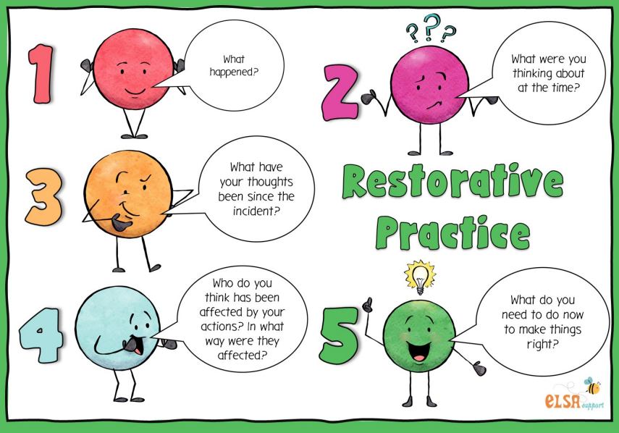

Appendix 4-Examples of Monday ‘Check In’ resources

Monday morning check-in – to set a positive tone for the week ahead. All staff in the classroom / year group should be involved in this which may make smaller groupings possible.

- "One Word" Check-in:
Ask children to share one word to describe how they are feeling today to build emotional literacy and show that you care about their well-being.
- A Look Ahead:
Ask children to share one thing they are looking forward to doing or learning this week to build excitement and purpose.
- Affirmation Statements:
Have the class say a simple positive affirmation together, like, "I am ready to learn," or "I can do my best today".
- A "How Are You Feeling?" Chart:
Create a simple chart with emojis for different feelings. Children can place a marker or a picture of themselves next to the emoji that represents them as they enter the room.
- "Gratitude Moment":
Have children share one thing they are thankful for. This helps foster a positive and grateful mindset.
- Affirmation Pass
Each person gives a positive comment to the person next to them. Builds confidence and a sense of belonging.
- Mindful Moment
A short breathing exercise or guided visualization. Helps everyone feel calm and focused.
- “What’s New?” Round
Staff and pupils share one new thing they learned, tried, or experienced recently. Encourages curiosity and sharing.
- Mini Quiz or Puzzle
A fun, themed quiz (e.g., “Guess the teacher’s favourite book”) or a brain teaser. Light-hearted and engaging.
- Music & Movement
Play an uplifting song and do a quick dance/stretch routine. Great for energizing and bonding.
- Weekly Intentions
Everyone sets a personal or group goal for the week. Can be written on a shared board or discussed in pairs.
- Kindness Bingo
Introduce a kindness challenge for the week (e.g., “Help someone,” “Say thank you”). Encourages positive behaviour and reflection.

Appendix 5-Solution Circle


